# **Autonomous Closed-Area Transport System for Seamless Mobility in Residential Complexes and Townships**

*Project Report*

*Submitted in the partial fulfillment of the requirements for the award of the degree of*

**BACHELOR OF TECHNOLOGY**

*IN*

**DEPARTMENT OF ELECTRICAL AND ELECTRONICS ENGINEERING**

By Batch-6

|  |  |
| --- | --- |
| **ID NUMBERS** | **NAMES** |
| 2200069004 | P. AEKANTH |
| 2200069018 | K. SAI SREENIVAS |
| 2200069021 | K. KOTESWARA RAO |
| 2200069033 | P .SOMA SEKHAR |
| 2200030263 | U. HIMAJA SREE SHARVANI |
| 2200032933 | J. ASWINI |

**under the supervision of**

# **Dr.D. Kalyan,**

# **(Assistant professor)**



Department of Electrical and Electronics Engineering

K L E F, Green Fields,

Vaddeswaram- 522502, Guntur(Dist), Andhra Pradesh, India.

November,2024

**Declaration**

The Project Report entitled “ **Autonomous Closed-Area Transport System for Seamless Mobility in Residential Complexes and Townships** “is a record of Bonafide work of 2200069004,2200069018,2200069021,2200069033 submitted in partial fulfillment for the award of B.Tech in Electrical and Electronics Engineering and 2200030263,2200032933 in the Computer Science and Engineering to the K L University. The results embodied in this report have not been copied from any other departments/University/Institute.

**Id Numbers Names**

2200069004 P.Aekanth

2200069018 K.Sai Sreenivas

2200069021 K.Koteswara Rao

2200069033 P.Soma Sekhar

2200030263 U.Himaja Sree Sharvani

2200032933 J. Aswini

**CERTIFICATE**

This is to certify that the Project Report entitled “**Autonomous Closed-Area Transport System for Seamless Mobility in Residential Complexes and Townships**” is being submitted by 2200069004,2200069018,2200069021,2200069033,2200030263,2200032933 submitted in partial fulfillment for the award of B.Tech in Electrical and Electronics Engineering and Computer Science and Engineering to the K L University is a record of bonafide work carried out under our guidance and supervision.

The results embodied in this report have not been copied from any other departments/ University/Institute.

## Signature of the Supervisor Signature of the PROJECT-

## Dr.D. Kalyan COORDINATOR

**Asst. Professor** **Dr.B. Jyothi**

## Signature of the HOD Signature of the External Examiner

**Dr.A.Pandian**

**ACKNOWLEDGEMENTS**

I am greatly indebted to our K L Deemed to be a university that has provided a healthy environment to drive me to achieve my ambitions and goals. I would like to express my sincere thanks to my project in charge, for the guidance, support, and assistance they have provided in completing this project.

I express my sincere gratitude and thanks to my project guide **Dr .D. Kalyan** for his novel association of ideas, encouragement, appreciation, and intellectual zeal which motivated us to venture into this project successfully.

I express sincere gratitude to our Coordinator **Dr. B. JYOTHI** for her leadership and constant motivation provided in the successful completion of our academic semester.

I record it as my privilege to deeply thank our pioneer **Dr. A. PANDIAN** HOD EEE for providing us the efficient faculty and facilities to make our ideas into reality.

I express my sincere gratitude to our principal **Dr. T. K. RAMAKRISHNA RAO** for his administration towards our academic growth.

Finally, it is pleased to acknowledge the indebtedness to all those who devoted themselves directly or indirectly to make this project report success.

.

**ABSTRACT**

The Autonomous Closed-Area Transport System for Seamless Mobility in Residential Complexes and Townships project aims to revolutionize urban mobility by designing and implementing a self-sustaining transportation network within residential areas. This innovative system integrates autonomous vehicles equipped with advanced Lidar sensors and advanced infrastructure to provide residents with efficient, safe, and environmentally friendly transportation solutions. The Lidar sensor enables the vehicles to accurately detect and respond to their surroundings, ensuring safe and smooth navigation.

The project objectives include improving mobility and accessibility, reducing traffic congestion and environmental pollution, enhancing safety and security, and integrating with existing public transportation systems. The expected outcomes include a fully functional autonomous transportation system, improved mobility and accessibility, reduced traffic congestion and environmental pollution, and enhanced safety and security. The project targets residents, local authorities, private transportation companies, and researchers, and has the potential to improve quality of life, reduce traffic congestion and environmental pollution, increase safety and security, and contribute to the development of autonomous transportation systems and smart cities**.**

**Table of Contents**

|  |  |  |
| --- | --- | --- |
| **S.NO** | **NAME OF THE CONTENT** | **PAGE NUMBER** |
| 1. | Introduction | 7 |
| 2. | Literature Survey | 10 |
| 3. | Theoretical Analysis | 15 |
| 4. | Experimental investigations | 22 |
| 5. | Experimental results | 27 |
| 6. | Future Scope of the Project | 36 |
| 7. | Conclusion | 3 |
| 8 | References | 37 |

**INTRODUCTION**

**1.1 Introduction**

In today’s rapidly advancing technological landscape, automation has become a cornerstone of innovation, transforming industries and shaping the future of mobility. Among these advancements, autonomous systems have emerged as a key focus area, promising efficiency, sustainability, and enhanced user experience across diverse applications. This project aims to design and implement an **Autonomous Navigation System**, utilizing **LiDAR X2**, **Raspberry Pi 4**, and state-of-the-art algorithms for real-time localization and mapping, specifically tailored for closed environments such as residential complexes, industrial zones, and other confined spaces.

Modern urban and industrial environments face challenges of space optimization, traffic management, and sustainability. Traditional transportation systems often struggle in closed areas, where the absence of predefined infrastructure, narrow pathways, and dynamic obstacles necessitate intelligent solutions. Our proposed system addresses these issues by enabling vehicles to navigate autonomously, map their surroundings in real-time, and respond to environmental changes with precision and reliability.

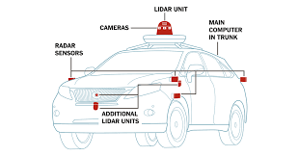

**Fig 1 Sensors Positions in Vehicle**

The system is built upon a synergy of advanced technologies:

1. **LiDAR X2:** A cutting-edge sensor that provides high-precision distance measurement and 2D mapping, critical for obstacle detection and environmental understanding.
2. **Raspberry Pi 4:** A compact and efficient computing platform that processes sensor data, executes control algorithms, and handles real-time decision-making.
3. **SLAM (Simultaneous Localization and Mapping):** A robust algorithmic framework that allows the system to dynamically build maps and localize itself within them, facilitating autonomous navigation in previously unmapped environments.
4. **Actuator Systems:** High-precision motors and servos for movement control, guided by advanced path planning and PID-based trajectory corrections.

The project focuses on achieving seamless integration of these components to deliver a system that can autonomously navigate, detect and avoid obstacles, and generate real-time visualizations of its operational environment. By incorporating data fusion techniques and sophisticated control logic, the system achieves precise localization and adaptive decision-making, ensuring efficiency and safety in its operation.

### **Motivation**

The motivation for this project arises from the growing demand for innovative and cost-effective solutions to automate mobility in closed environments. Unlike open spaces where GPS-based navigation systems are effective, confined areas such as residential complexes, warehouses, and industrial parks present unique challenges:

* **Limited Infrastructure:** Absence of predefined roadways or navigation aids necessitates systems capable of self-reliant operation.
* **Dynamic Environments:** Constantly changing conditions, such as moving obstacles, require real-time decision-making and adaptive behavior.
* **Cost Constraints:** Traditional high-cost autonomous systems remain inaccessible to small-scale or specialized use cases.

Our project is driven by the vision of making advanced autonomous technology accessible, scalable, and reliable for these specialized applications. The inclusion of **LiDAR X2** ensures precise mapping and obstacle detection, while the **Raspberry Pi** platform provides a cost-efficient yet powerful computational backbone. The use of open-source tools and frameworks, such as **ROS (Robot Operating System)**, further enhances the project’s scalability and adaptability.

The broader aim is to address the inefficiencies of current systems, such as dependency on GPS or reliance on pre-mapped routes, and introduce a system capable of autonomous exploration, mapping, and navigation. This innovation contributes to reducing environmental impact, improving operational efficiency, and paving the way for smart transportation systems in urban and industrial contexts.

**LITERATURE SURVEY**

Autonomous navigation systems are at the forefront of modern technological advancements, with applications ranging from industrial automation to residential mobility solutions. These systems integrate various hardware and software components to achieve precise localization, mapping, and navigation. This section provides an overview of existing research and technological developments in the fields of autonomous navigation, sensor integration, and mapping algorithms, highlighting the challenges and opportunities addressed by the proposed project.

**1. Autonomous Navigation Systems**

**1.1 Evolution of Autonomous Navigation**

The journey of autonomous systems began with basic remote-controlled vehicles and has since progressed to sophisticated machines capable of operating independently. Early systems relied on predefined paths and external guidance, but modern autonomous systems incorporate real-time sensing and adaptive decision-making. These advancements have enabled applications in areas such as:

* **Warehouse Automation:** Autonomous robots that transport goods efficiently.
* **Residential Mobility:** Systems designed for internal transport within gated communities.
* **Industrial Automation:** Vehicles capable of navigating factory floors with minimal human intervention.

**1.2 Importance in Closed Environments**

Confined spaces like residential complexes and industrial facilities present unique challenges, such as:

* Limited space for movement.
* Dynamic obstacles, including moving people or vehicles.
* Absence of GPS signals for localization.

Autonomous systems for these environments need to operate without external infrastructure, relying solely on onboard sensors and algorithms to navigate and make decisions. The proposed system builds on these needs, focusing on real-time mapping, localization, and efficient path planning.

**2. Sensor Technologies**

**2.1 LiDAR Sensors**

LiDAR (Light Detection and Ranging) is a game-changing technology for autonomous systems. It works by emitting laser beams and measuring the time taken for the reflected light to return, providing accurate distance measurements. Studies have highlighted the use of LiDAR for:

* **Obstacle Detection:** Identifying and avoiding objects in real-time.
* **Mapping:** Creating detailed 2D and 3D maps of the environment.

The **YD LiDAR X2**, chosen for this project, offers several advantages:

* **Range:** Detects obstacles up to 12 meters away.
* **Resolution:** High angular resolution of 0.5°, ensuring detailed mapping.
* **Speed:** Processes up to 8,000 data points per second.

These features make the LiDAR X2 ideal for confined environments, where precision and real-time responsiveness are critical.

**2.2 Sensor Fusion**

LiDAR’s capabilities can be enhanced by integrating data from other sensors, such as wheel encoders. Sensor fusion combines data from multiple sources to improve the accuracy of localization and mapping. For example, while LiDAR provides spatial information, encoders measure wheel rotations to estimate movement. Together, these inputs create a robust understanding of the vehicle’s position and surroundings.

**3. Computational Platforms**

**3.1 Raspberry Pi**

The **Raspberry Pi 4** has become a preferred platform for low-cost autonomous systems due to its versatility and affordability. Key features include:

* **Processing Power:** A quad-core Cortex-A72 processor capable of handling sensor data and control logic.
* **Flexibility:** Interfaces for GPIO pins, USB, and serial communication, making it compatible with sensors like LiDAR.
* **Energy Efficiency:** Low power consumption, ideal for mobile systems.

The Raspberry Pi acts as the brain of the system, processing data from LiDAR, executing navigation algorithms, and controlling actuators in real-time.

**4. Mapping and Localization**

**4.1 Mapping with LiDAR**

Mapping involves creating a spatial representation of the environment. LiDAR generates a point cloud of the surroundings, which is then processed to produce a 2D occupancy grid or map. This map helps the system understand:

* Free spaces for movement.
* Obstacles to avoid.
* Optimal paths for navigation.

For example, the LiDAR X2 scans its environment and plots the distance to various objects, enabling the system to dynamically build a map while navigating.

**4.2 Localization Without GPS**

Localization is the process of determining the vehicle's position within the map. Unlike open environments where GPS is used, closed environments require internal methods. Localization in this project is achieved through:

* Matching real-time LiDAR data with the generated map.
* Using encoder data to estimate movement and adjust the vehicle's position.

This combination ensures accurate and reliable localization even in confined and GPS-denied spaces.

**5. Path Planning and Actuator Control**

**5.1 Path Planning**

Path planning determines the most efficient route from the current location to the destination. Traditional algorithms like A* and Dijkstra are widely used for this purpose. These algorithms calculate:

* **Shortest Path:** Minimizing distance or time.
* **Obstacle Avoidance:** Ensuring a collision-free route.

**5.2 Actuator Control**

Precise control of actuators is critical for smooth navigation. This project uses:

* **DC Motors:** For forward and backward movement.
* **Steering Servos:** To adjust the vehicle's direction.

A **PID (Proportional-Integral-Derivative)** controller ensures that the vehicle follows the planned path accurately. It adjusts motor speed and steering angle based on real-time feedback from the sensors.

**6. Challenges in Existing Systems**

**6.1 High Costs**

Many autonomous systems rely on expensive components, making them inaccessible for smaller-scale applications. This project addresses this by using affordable technologies like Raspberry Pi and LiDAR X2.

**6.2 GPS Dependency**

Traditional navigation systems depend heavily on GPS, limiting their use in enclosed spaces. The proposed system eliminates this dependency by leveraging onboard sensors and algorithms for localization.

**6.3 Real-Time Performance**

Real-time responsiveness is a major challenge in dynamic environments. The system overcomes this by optimizing data processing and control algorithms for the Raspberry Pi’s capabilities.

**7. Summary of Findings**

The literature and survey highlight several critical insights:

* LiDAR is a reliable and precise tool for real-time mapping and obstacle detection.
* Sensor fusion improves localization accuracy by combining spatial and movement data.
* Low-cost platforms like Raspberry Pi make advanced autonomous systems accessible.
* Efficient path planning and control algorithms are essential for smooth and reliable navigation.

The proposed system builds upon these findings to create a robust, efficient, and scalable autonomous navigation solution tailored for confined environments. By addressing the limitations of existing systems and leveraging cost-effective technologies.

**THEORETICAL ANALYSIS**

The proposed project represents a seamless blend of advanced hardware and intelligent software, designed to create an autonomous navigation system capable of operating in confined environments. It integrates key components like LiDAR, Raspberry Pi, Arduino UNO, and DC motors into a cohesive system that leverages real-time data processing, mapping, and actuator control to achieve reliable and adaptive movement. This section provides a comprehensive yet humanized analysis of the technology and its integration within the system.

**1.LiDAR Technology: The Eyes of the System**

LiDAR, or Light Detection and Ranging, serves as the sensory core of the system. It provides the vehicle with the ability to “see” its surroundings by emitting laser beams and measuring their reflection time. The critical outputs of the LiDAR sensor include:

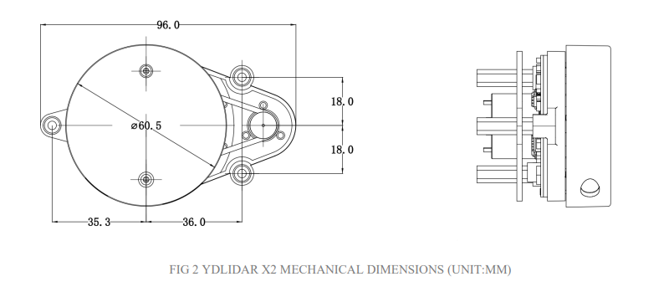

**Fig 2 Measurements of X2 LIDAR**

**Fig 3 Directions of X2 LIDAR**

* **Distance:** Tells how far an object or obstacle is from the sensor.
* **Angle:** Determines the relative position of the object within the environment.
* **Intensity:** Indicates how reflective or dense the detected object is, which can help classify obstacles.

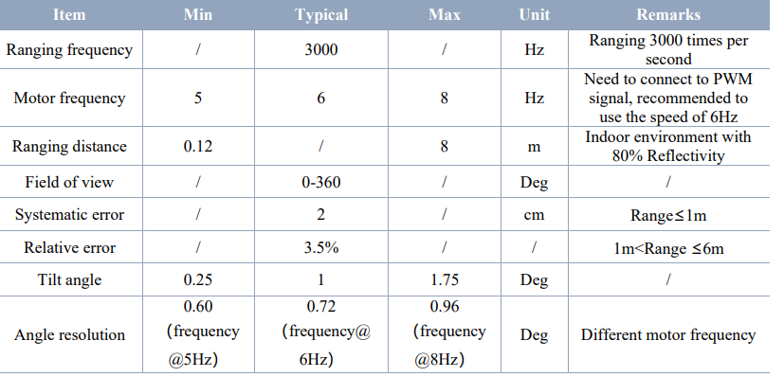

**Table 1 LiDAR Sensor Specifications**

The **YD LiDAR X2**, chosen for this project, is compact, precise, and highly responsive. With a detection range of 12 meters, it captures a detailed 2D snapshot of the environment. This information is critical for building maps and identifying obstacles in real time, ensuring the vehicle can navigate even complex spaces.

**Fig 4 Pin configuration of X2 Lidar**

Table: 2 Lidar Pin Configuration and Descriptions

**2. Raspberry Pi: The Brain of the System**

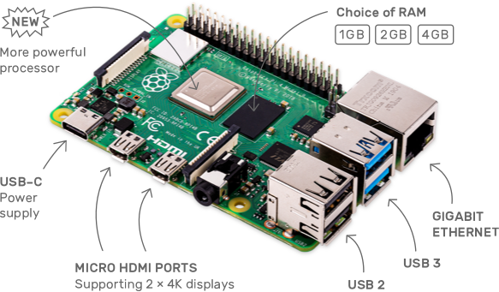

Fig 5 Raspberry Pi 4

The Raspberry Pi acts as the computational core, managing data flow and decision-making. This lightweight yet powerful microcontroller processes the incoming LiDAR data and executes algorithms to make real-time decisions. Its key responsibilities include:

1. **Data Processing:** The Raspberry Pi converts raw LiDAR data into actionable insights, such as identifying free paths and detecting obstacles.
2. **Mapping and Navigation:** Using algorithms, it creates a dynamic 2D map of the environment and calculates the best possible route to the target location.
3. **System Coordination:** It communicates with the Arduino UNO to relay instructions to the motors, ensuring synchronized movement.

By centralizing computational tasks, the Raspberry Pi ensures that the system remains efficient and responsive, even in dynamic conditions.

**3. Path Planning and Decision Making: The Algorithm**

At the heart of the system lies the algorithm—a set of logical instructions that enable the vehicle to make decisions autonomously. The algorithm consists of:

* **Mapping:** Converts the LiDAR data into a 2D grid map, highlighting free spaces, obstacles, and paths.
* **Path Planning:** Using techniques like the A* algorithm, it determines the shortest and safest route from the current position to the destination.
* **Obstacle Avoidance:** Dynamically adjusts the path in response to moving or newly detected obstacles, ensuring a collision-free operation.

This decision-making capability mimics how humans assess and navigate their surroundings, making the system intelligent and adaptive.

1. **Arduino UNO: The Communication Bridge**

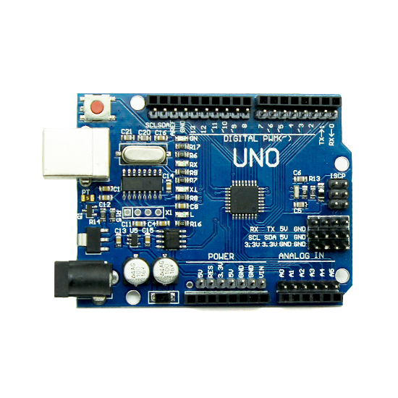

Fig 6 Arduino UNO

The Arduino UNO plays the role of a translator and controller. It acts as an intermediary between the Raspberry Pi and the motor driver module, ensuring smooth and accurate communication. Its primary functions are:

* **Signal Translation:** Converts high-level navigation commands from the Raspberry Pi into low-level signals that the motor driver module can understand.
* **PWM Signal Generation:** Controls the speed and direction of the motors by generating precise PWM (Pulse Width Modulation) signals.
* **Error Handling:** Ensures stable motor control by handling fluctuations in input signals.

The Arduino adds robustness to the system, ensuring reliable actuator control even under varying conditions.

1. **Motor Driver Module: The Muscle Behind the Movement**

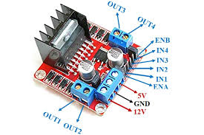

Fig 7 L298 Motor Driver Module

The **L298 Motor Driver Module** translates electrical commands into physical motion by controlling the DC motors. It plays a vital role in:

* **Power Management:** Distributing electrical power to the motors based on commands from the Arduino.
* **Direction Control:** Adjusting motor polarity to enable forward, backward, and turning movements.
* **Synchronization:** Ensuring all motors work in harmony for smooth navigation.

This module acts as the vehicle’s "muscles," converting electrical energy into controlled motion.

**6. DC Motors and Powertrain: The Movement Mechanism**

The system uses four DC motors to provide the vehicle with stability and precise control. These motors are connected to the wheels through a powertrain mechanism, ensuring efficient torque distribution. Key features include:

* **Speed Control:** Adjustments to motor speed allow for smooth acceleration and deceleration**.**
* **Directional Movement:** The motors work together to allow the vehicle to move straight, rotate.
* **Load Handling:** The motors are designed to handle varying loads, ensuring consistent performance across different terrains.

The combination of well-synchronized motors and a robust powertrain ensures that the vehicle can navigate even complex environments with ease.

**7. External Power Supply: The Energy Source**

An external power supply provides energy to the entire system, including the Raspberry Pi, Arduino, LiDAR, and motors. Key considerations for the power supply include:

* **Battery Capacity:** Must support extended operational hours.
* **Voltage Stability:** Ensures that each component receives the correct voltage for optimal performance.
* **Efficiency:** Minimizes energy loss to extend the operational life of the system.

A well-designed power supply ensures that the system remains operational under varying conditions.

**8. Integration: Bringing It All Together**

The true strength of the system lies in its integration. Each component—LiDAR, Raspberry Pi, Arduino, and the motors—works in harmony to create a fully autonomous vehicle. The workflow is as follows:

1. **Data Collection:** LiDAR captures environmental data (distance, angle, intensity) and sends it to the Raspberry Pi.
2. **Data Processing:** The Raspberry Pi processes the data to build a map, identify obstacles, and calculate the optimal path.
3. **Signal Transmission:** The Raspberry Pi sends navigation commands to the Arduino UNO, which translates them into motor control signals.
4. **Actuation:** The motor driver module executes the commands, propelling the vehicle along the planned path.
5. **Feedback Loop:** Real-time updates from the LiDAR ensure that the vehicle continuously adapts to its surroundings.

**EXPERIMENTAL INVESTIGATIONS**

The experimental phase of this project was focused on testing the integration and performance of all components in the system, from LiDAR and Raspberry Pi to the motors and navigation algorithms. These tests were conducted to ensure the system works seamlessly in real-world scenarios, including confined spaces and dynamic environments. The following summarizes the experiments, findings, and insights in a simple and approachable manner.

**LiDAR X2 Data Visualization**

The above image represents a plot of data obtained from a single scanning cycle of the **LiDAR X2 sensor**, which was used to capture the surrounding environment in a confined space. This visualization highlights the LiDAR’s ability to detect and map obstacles in real-time, forming the basis for the autonomous navigation system's decision-making processes.

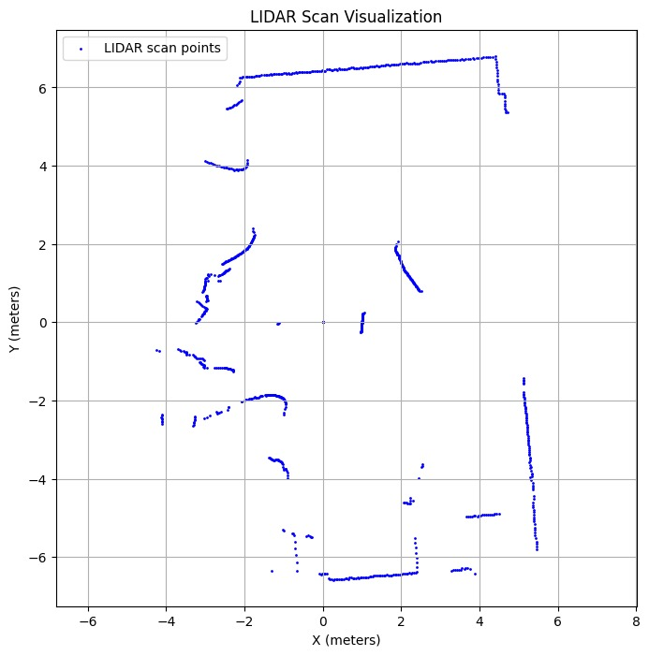

## Fig 8 LiDAR X2 Data Visualization

**Details of the Experiment**

* **Sensor Used:** LiDAR X2
* **Data Samples:** 1,049 points in one scanning cycle.
* **Baud Rate:** 115,200, ensuring high-speed data transfer between the LiDAR sensor and the processing unit (Raspberry Pi).
* **Visualization Method:** Python-based plotting using libraries like Matplotlib to visualize the scan points in a 2D space.

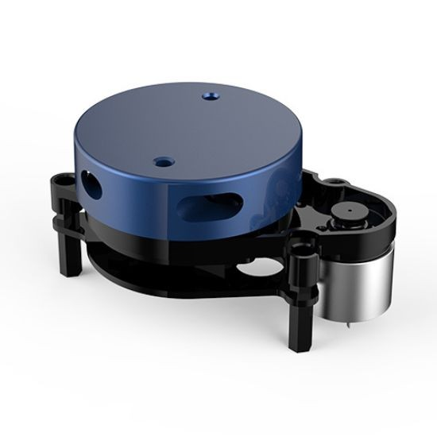

Fig 9 X2 LIDAR

**Objective of the Experiment**

The primary objective was to:

1. Validate the LiDAR X2's performance in capturing precise distance and angular data points within a confined environment.
2. Analyze the accuracy and density of scan points to identify obstacles and free spaces.
3. Test the system's ability to use the LiDAR data for mapping and real-time navigation.

**Experimental Procedure**

1. **Setup:**
   * The LiDAR X2 was mounted on a stationary platform and connected to a Raspberry Pi via a serial connection.
   * The surrounding environment consisted of walls, objects, and open spaces to simulate a real-world scenario.

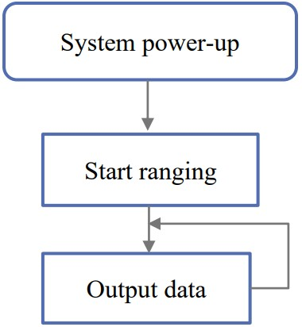

Fig 10 working of x2 lidar

1. Data Collection:
   * The LiDAR emitted laser beams in a 360-degree sweep, collecting data points for distances and angles relative to its position.

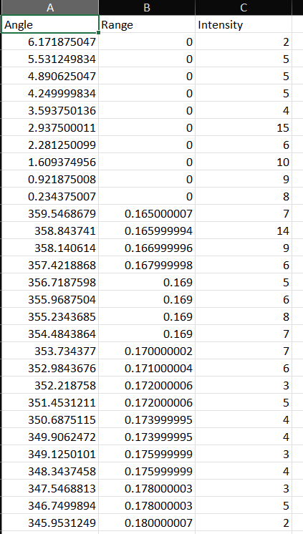

Fig 11 Observed Data of X2 LIDAR

* + A total of 1,049 data points were captured in a single scanning cycle.

1. **Data Processing:**
   * The data, received as distance and angle pairs, was converted into Cartesian coordinates (X, Y) for 2D visualization.
   * The Python script processed the data and plotted the results to represent the detected objects and boundaries.
2. **Visualization:**
   * Each point in the plot corresponds to a detected object or surface in the environment.
   * The X and Y axes denote the position of these objects relative to the LiDAR's origin in meters.

**Observations**

1. **Scan Density:**
   * The LiDAR produced a dense set of points, enabling detailed mapping of the environment.
   * Fine details, such as corners and small gaps, were successfully captured.
2. **Obstacle Detection:**
   * Vertical walls and larger objects were clearly visible in the plot as continuous lines of points.
   * Scattered points represented smaller or less reflective objects, indicating the sensor's sensitivity to surface properties.
3. **Accuracy:**
   * The plotted distances and angles aligned well with the actual layout of the environment.
   * The angular resolution of 0.5° ensured precise localization of obstacles.
4. **Performance:**
   * With a baud rate of 115,200, data transmission was smooth and lag-free, enabling real-time visualization.
5. **Limitations:**
   * Some scattered or missing points were observed, likely caused by highly reflective or transparent surfaces (e.g., glass).
   * Detection accuracy decreased slightly for objects at the sensor’s maximum range (8 Meters).

**EXPERIMENTAL RESULTS**

**Block Diagram**

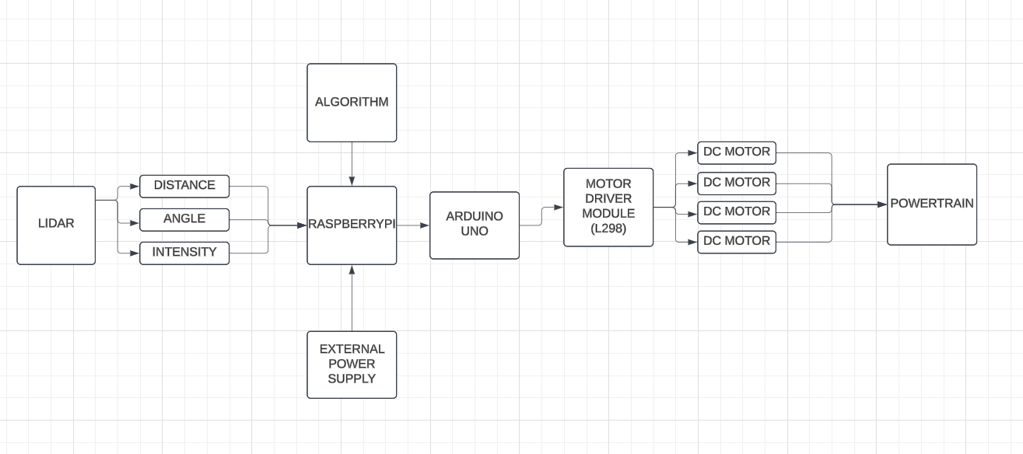

Fig 12 Block Diagram

The block diagram illustrates the workflow of an autonomous navigation system, where each component plays a critical role in ensuring smooth operation. At the core of the system is the **LiDAR sensor**, which acts as the "eyes," scanning the environment by emitting laser beams and measuring the reflected signals to determine the distance, angle, and intensity of surrounding objects. This data is sent to the **Raspberry Pi**, the "brain" of the system, which processes the information using a programmed algorithm. The algorithm interprets the LiDAR data to create a 2D map of the environment, detect obstacles, and calculate the optimal path to the destination. Once the decisions are made, the Raspberry Pi communicates with the **Arduino UNO**, which serves as the "translator," converting high-level navigation commands into motor-friendly signals using Pulse Width Modulation (PWM). These signals are sent to the **L298 Motor Driver Module**, the "power distributor," which supplies the appropriate voltage and current to the **DC motors**, ensuring smooth propulsion and directional control. The **motors**, acting as the system's "legs," drive the wheels through the **powertrain**, enabling precise movement of the vehicle. All components are powered by an **external power supply**, ensuring consistent energy delivery to keep the system operational. Together, these components form a cohesive system where the LiDAR provides situational awareness, the Raspberry Pi processes and plans, and the Arduino and motor modules execute the actions, resulting in a fully autonomous navigation system capable of avoiding obstacles and reaching its destination efficiently.

**Flow Chart**

Fig 13 Flow Chart

The flowchart illustrates the logical sequence of how the autonomous navigation system operates, starting from data acquisition to obstacle avoidance and reaching the destination. Initially, the system begins with the LiDAR sensor and Raspberry Pi, where the LiDAR collects environmental data such as angle, range, and intensity. This data is then transferred to the Raspberry Pi, which processes it to understand the surroundings. The processed data is sent to the motor controller (L298N) via the Arduino through serial communication to control the vehicle's movements.

The decision-making process starts with the algorithm analyzing the environment for obstacles. If an obstacle is detected, the system evaluates its position. If the obstacle is on the left side, the system instructs the vehicle to move to the right. Conversely, if the obstacle is on the right, the vehicle moves to the left. If no obstacles are encountered, the system allows the vehicle to proceed directly toward its destination. Once the destination is reached, or the process is complete, the system exits. This flow ensures the vehicle can navigate dynamically, avoiding obstacles and efficiently reaching its destination, all while maintaining smooth operation.

**Hardware Setup:**

The hardware setup for the autonomous vehicle comprises a Lidar sensor mounted at the front for real-time obstacle detection and environmental mapping, with data processed by a Raspberry Pi 4, serving as the central processing unit. The Raspberry Pi analyzes the Lidar data and communicates navigation commands to an Arduino, which, in conjunction with a motor driver, controls the DC motors powering the vehicle's wheels. All components are mounted on a sturdy wooden chassis, providing a stable platform for the system. Separate power supplies are used for the Raspberry Pi and the motor driver to ensure reliable operation, while organized jumper wires facilitate seamless communication and power distribution between sensors, controllers, and actuators. This integrated setup enables the vehicle to navigate efficiently and avoid obstacles autonomously.

Fig14 Side View of Vehicle

Fig15 Front View of Vehicle

Fig 16 Top View of Vehicle

**1. Chassis:**

* The wooden chassis is lightweight and has pre-drilled slots and holes for easy mounting of hardware like the Raspberry Pi, Lidar sensor, and motor driver.
* It also provides stability for the vehicle while it moves.
* The Raspberry Pi and motor driver are securely mounted on top of the chassis using screws or spacers, keeping the wiring manageable and protected.

**2. Wheels and Motors:**

* Four wheels are visible, likely powered by DC motors, enabling movement. The motors are mounted on the chassis and are likely controlled via a motor driver module.

**3. Raspberry Pi (Processing Unit):**

* Functionality:
  + Acts as the central processing unit for the vehicle.
  + Likely runs a Python or ROS (Robot Operating System) script to process inputs from the Lidar sensor and send control signals to the motor driver.
  + Manages wireless communication (via Wi-Fi or Bluetooth) for remote control or data transmission.
* Connections:
  + GPIO pins are used to interface with the motor driver for motor control signals.
  + A USB port might connect to the Lidar sensor or other peripherals.

**4. Motor Driver (L298N):**

* The red module in the center with two heat sinks is an L298N motor driver, which controls the DC motors. It is connected to both the Raspberry Pi and the motors to manage motor speed and direction.

**5. Lidar Sensor (Blue Device):**

* Functionality:
  + Scans the environment to detect obstacles and map the surroundings by emitting laser beams and measuring the reflected signals.
  + Likely used for navigation and path planning in this setup.
* Placement:
  + Positioned at the front of the chassis for a wide field of view.
  + Mounted securely to prevent vibration, which could affect accuracy.
* Connection:
  + Transmits data to the Raspberry Pi via USB or UART interface.
  + Requires its own power supply, which might be provided through the Raspberry Pi.

Fig 17 Received Data from LIDAR X2 in Terminal

This image represents data collected from a YDLidar X2 sensor during a single scan cycle, processed by a Raspberry Pi 4.

**1. Lidar Scanning Process:**

* The **Lidar sensor** performs a 360-degree scan of the environment and collects **1049 samples** during one complete cycle.
* Each sample corresponds to:
  + The **angle** at which the measurement was taken.
  + The **distance** from the sensor to an object or obstacle at that angle.
  + Other data like the intensity of the laser reflection and status information.

**2. Key Information Displayed:**

* **Largest Distance Detected:**
  + The system identifies the **largest distance** detected by the Lidar, which is **9.278 meters** in this scan.
  + The **angle** where this distance was recorded is **-12.52°**, indicating it is slightly to the left of the robot's forward direction.
* **Direction Assignment:**
  + Based on the angle, the system determines the relative **direction**:
    - **a** = Left (angles left of the center).
    - **d** = Right (angles right of the center).
    - **w** = Forward (angles near the center or directly ahead).
    - **s** = Backward (angles behind the robot).
  + For the largest detected distance, the **direction is left** (since -12.52° is on the left).

**3. Command Sent to Arduino:**

* After processing the data, the Raspberry Pi sends a **command** via **serial port communication** to the Arduino.
* In this case:
  + The command sent is **"a"**, indicating that the robot should turn **left** towards the area with the largest open space or least obstacles.
  + This command allows the robot to move safely and avoid collisions while navigating.

**4. Process Flow Summary:**

1. The Lidar sensor scans the surroundings and collects distance and angle data.
2. The Raspberry Pi processes the data to find:
   * The largest distance.
   * The corresponding angle and relative direction.
3. Based on the identified direction, a control command ("a," "d," "w," or "s") is sent to the Arduino, which handles the movement of the robot (e.g., turning left, right, moving forward, or backward).

"The autonomous vehicle receives navigation commands from the Raspberry Pi 4, which analyzes data from the Lidar sensor. Based on the largest detected distance and its direction, the Pi sends an instruction to the Arduino, like 'a' for left, 'd' for right, 'w' for forward, or 's' for backward. Upon receiving the command, the Arduino adjusts the motor controls, guiding the vehicle to travel in the specified direction, ensuring it moves towards the safest and most open path while avoiding obstacles."

**CONCLUSION**

The **Autonomous Closed-Area Transport System** is designed to address the mobility needs within residential complexes and townships by providing a sustainable, efficient, and user-friendly transportation solution. The system eliminates the dependency on personal vehicles, reducing traffic congestion and promoting an eco-friendly environment.

The core of this system involves **autonomous vehicles**, such as shuttles or pods, equipped with advanced technologies like **LIDAR sensors**, **GPS**, and **AI-based navigation systems**. These vehicles operate within predefined routes and boundaries, ensuring safe and efficient transportation for residents and visitors. Users can request rides via mobile apps or kiosks, making the system highly convenient and accessible.

The vehicles are powered by **electric motors** to ensure low emissions and are controlled by **microcontrollers** such as Arduino or Raspberry Pi, integrated with motor driver modules for precise movement. LIDAR and other sensors play a critical role in obstacle detection and route optimization, enhancing safety and reliability.

This transport system aims to improve the quality of life by providing seamless mobility while contributing to environmental sustainability. The project demonstrates the potential of combining automation, smart technologies, and sustainable practices to solve modern urban mobility challenges effectively.

**FUTURE SCOPE OF THE PROJECT**

The future of the **Autonomous Closed-Area Transport System** lies in its ability to transform short-distance mobility within residential complexes and college campuses. By integrating **solar panels** on top of the self-driving vehicles, the system ensures **renewable energy utilization** for sustainable operation. Vehicles will automatically charge using solar energy while stationary or driving under sunlight, significantly reducing energy costs and environmental impact. This **auto solar charging feature** enhances energy efficiency, enabling a greener transportation alternative and reducing dependence on external charging infrastructure.

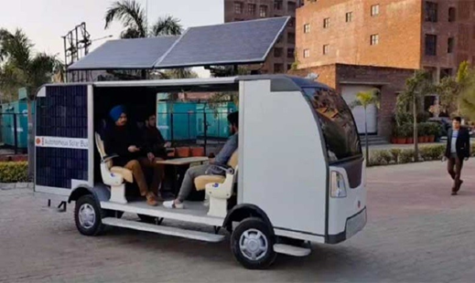

Fig 18 Future scope

In residential areas, it can seamlessly connect different blocks, offering residents a convenient, cost-effective travel option. Similarly, in **college campuses**, the system can transport students and faculty between buildings, ensuring punctuality and minimizing reliance on traditional vehicles. The vehicles’ **AI-powered navigation system** will improve safety and optimize routes, while **IoT-based monitoring** will ensure real-time energy usage and maintenance alerts. These solar-powered self-driving vehicles align with global sustainability goals, providing **eco-friendly, reliable, and inclusive mobility solutions** for all users, including the elderly and differently-abled individuals. The implementation of **smart parking** and **solar charging stations** will further streamline operations and reduce system downtime. By adopting this technology, residential complexes and campuses can lead the way in **sustainable innovation**, creating smarter, greener, and more connected communities.

**References**

1. Impact of Autonomous Shuttle Systems on Urban Mobility Author(s): Liu, X., Zhang, Y ,Journal of Transport Geography ,2022
2. A. L. Meyrowitz, D. R. Blidberg and R. C. Michelson, "Autonomous vehicles," in Proceedings of the IEEE, vol. 84, no. 8, pp. 1147-1164, Aug. 1996, doi: 10.1109/5.533960.
3. C. Urmson and W. ". Whittaker, "Self-Driving Cars and the Urban Challenge," in IEEE Intelligent Systems, vol. 23, no. 2, pp. 66-68, March-April 2008, doi: 10.1109/MIS.2008.34.
4. K. Jo, M. Lee, W. Lim and M. Sunwoo, "Hybrid Local Route Generation Combining Perception and a Precise Map for Autonomous Cars," in IEEE Access, vol. 7, pp. 120128-120140, 2019, doi: 10.1109/ACCESS.2019.2937555.
5. P. Y. Leong and N. S. Ahmad, "LiDAR-Based Obstacle Avoidance With Autonomous Vehicles: A Comprehensive Review," in IEEE Access, vol. 12, pp. 164248-164261, 2024, doi: 10.1109/ACCESS.2024.3493238
6. G. Bresson, Z. Alsayed, L. Yu and S. Glaser, "Simultaneous Localization and Mapping: A Survey of Current Trends in Autonomous Driving," in IEEE Transactions on Intelligent Vehicles, vol. 2, no. 3, pp. 194-220, Sept. 2017, doi: 10.1109/TIV.2017.2749181.
7. R. Hussain and S. Zeadally, "Autonomous Cars: Research Results, Issues, and Future Challenges," in IEEE Communications Surveys & Tutorials, vol. 21, no. 2, pp. 1275-1313, Secondquarter 2019, doi: 10.1109/COMST.2018.2869360.
8. S. Shashaani, M. Teshnehlab, A. Khodadadian, M. Parvizi, T. Wick and N. Noii, "Using Layer-Wise Training for Road Semantic Segmentation in Autonomous Cars," in IEEE Access, vol. 11, pp. 46320-46329, 2023, doi: 10.1109/ACCESS.2023.3255988.
9. P. Y. Leong and N. S. Ahmad, "LiDAR-Based Obstacle Avoidance With Autonomous Vehicles: A Comprehensive Review," in IEEE Access, vol. 12, pp. 164248-164261, 2024, doi: 10.1109/ACCESS.2024.3493238.
10. A. Thakur and P. Rajalakshmi, "LiDAR-Based Optimized Normal Distribution Transform Localization on 3-D Map for Autonomous Navigation," in IEEE Open Journal of Instrumentation and Measurement, vol. 3, pp. 1-11, 2024, Art no. 8500211, doi: 10.1109/OJIM.2024.3412219.